Abstract:
This paper presents the development and implementation of a feedforward artificial neural network (ANN) designed to classify handwritten digits. The core challenge addressed is teaching a neural network to reliably associate complex visual input with its correct label.
Our methodology uses a dense, neural network architecture featuring an input layer of 784 neurons, two hidden layers of 16 neurons each, and a 10-neuron output layer. For linear transformations between layers, the network uses three weight matrices (W₁ ​,W₂ ​,W₃​), followed by the sigmoid function for activation. The forward process then computes the predicted output. The training of the model’s network is facilitated by backpropagation and gradient descent, where the squared error is reduced with respect to the weights and biases using partial derivatives.

Results show that by repeatedly adjusting weights and biases based on the gradient, the network is trained to recognize the features and edges within the input images, enabling digit classification. Furthermore, by using matrix operations, the computation can be made more efficient during both the forward and backpropagation steps.

In conclusion, this project successfully applies linear algebra, to create an intelligent system capable of carrying out high-accuracy pattern recognition for the task of handwritten digit classification.

Body:

When we see something—such as a butterfly—we can immediately identify it as a butterfly. However, this ability is not innate for everyone. For example, a child does not automatically know that the insect they are observing is called a butterfly. Instead, adults take on the responsibility of explaining and labeling objects in the child’s environment. The child receives the visual input of the insect, and through repeated teaching, they learn its name. After learning, the child can recognize a butterfly on sight.
Similarly, an artificial neural network must undergo a training process. During training, the network is repeatedly shown input data along with the correct labels. Over time, it learns to associate specific input patterns with their corresponding outputs. Once trained, the neural network can recognize similar inputs—just as a child eventually learns to identify a butterfly.
For recognizing (or predicting) an image, we refer to this procedure as the forward process. This forward process can be understood analogously to evaluating a function f(x), where x is the input and f(x) is the corresponding output (similar to how the visual input is the insect and the output is the identification “butterfly”). In our program, the input is a 28×28 image containing a total of 784 pixels. We represent these 784 pixels as a vector in $R^{784}$ :
$$x=\left(\begin{matrix}x_{1} \\ x_{2} \\ ⋮x_{784}\end{matrix}\right)$$
Think of each individual pixel as a neuron or a parameter that holds data, in this case, an activation number between 0 and 1 that represents how strongly the pixel lights up (0 dark, 1 white).
The output consists of 10 elements, corresponding to the digits 0 through 9. We represent this as a vector in $R^{10}$ where the element’s value corresponding to the correct digit is set to 1, and all other elements are set to 0:
$$y=\left(\begin{matrix}y_{0} \\ y_{1} \\ ⋮y_{9}\end{matrix}\right)$$
For example, a digit 3 will become a vector:
$$3 = \begin{matrix}0 \\ \begin{matrix}0 \\ \begin{matrix}0 \\ \begin{matrix}1 \\ \begin{matrix}... \\ 0\end{matrix}\end{matrix}\end{matrix}\end{matrix}\end{matrix}$$
In MTH 160, we learned that a linear transformation from $R^{n}$ to $R^{m}$ can be represented by a matrix. Likewise, in neural networks, we multiply the input vector by a matrix—called the weight matrix—to transform the 784-dimensional input into a 10-dimensional output.
$$[y=Wx + b]$$
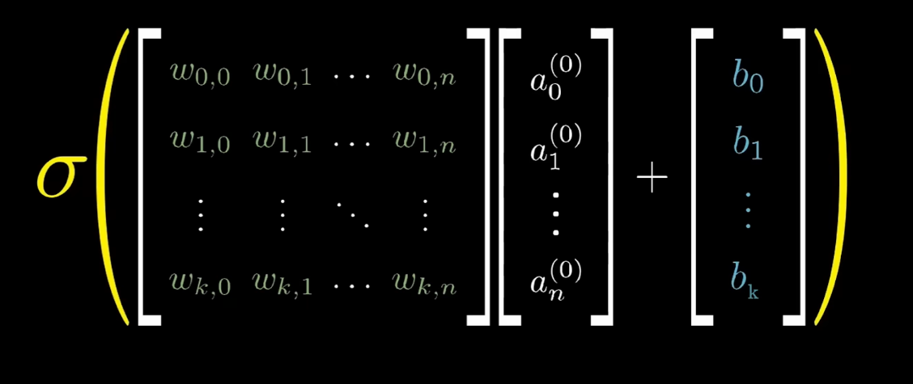
Representation of multiplying the Weight matrix with our pixels vector
Weights determine how strongly each element of input contributes to the output—essentially indicating how important a given neuron is in producing the correct prediction. A positive weight pushes the output upward, while a negative weight pushes it downward. If a feature contributes to predicting the correct outcome, its weight increases; if it does not, the weight decreases.
For example, consider a linear equation in the weight multiplication:
$$N_{1}=W_{11} {\text{pixel}}_{1}+W_{12} {\text{pixel}}_{2}+⋯+W_{1,784} {\text{pixel}}_{784}.$$
If a pixel—such as pixel 1, which stays at the edge of the image—is not likely to light up, then its corresponding weight will gradually decrease during training.
These weights are initially chosen randomly and then adjusted through a process called gradient descent (discussed later). The iterative adjustment of these weights is known as backpropagation, which tunes them to values that move the network toward the correct output.
Another component of the network is the bias, a value that shifts the activation threshold. The bias allows a neuron to activate only when the combined input surpasses a certain level, giving the model more flexibility and improving its ability to fit the data. In this layer, we apply the sigmoid activation function to keep the output values between 0 and 1, ensuring consistency across all neurons.
In our program, using only one weight matrix would not provide sufficient accuracy. Therefore, we include two hidden layers, each containing 16 neurons, between the input layer and the final output layer. Think of these layers as a process of breaking the digit into distinct shapes and edges, then combining these parts to determine the most likely number. The first layer is our image of the digit represent as a vector. The next layer analyzes smaller sub-regions within the area where pixels light up (breaking down to 16 edges or shapes). The following layer integrates these sub-regions into more complex patterns. Finally, the output layer uses this information to predict the digit. This hierarchical breakdown is illustrated well in 3Blue1Brown’s visualization of how a neural network interprets hand-drawn numbers.
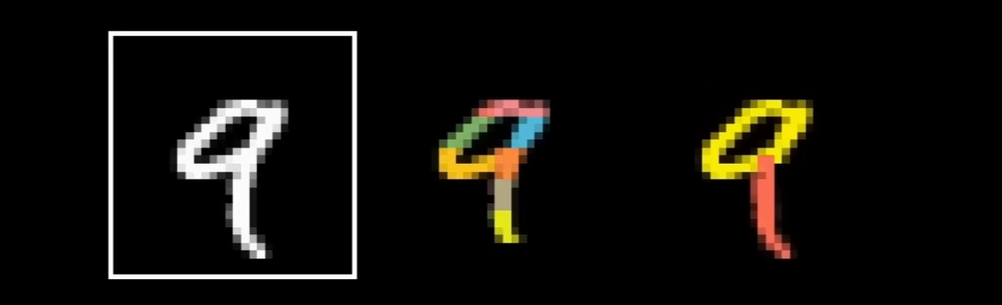
Breaking a number to edges
As a result, we will have three weight matrices (W1, W2, and W3) to perform the linear transformations between the layers.
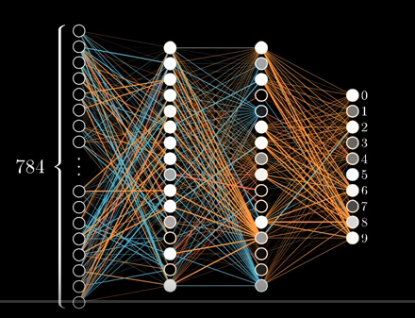
Representation of our Neural Network with 2 hidden layers
Initializing our neural network class with Python code:
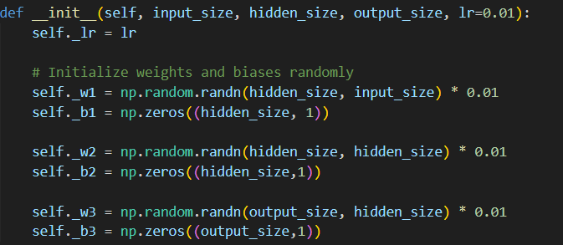
Snippet of code for initialization
self._w1, self._w2, and self._w3 are the weight matrices of our neural network. All weight matrices are initialized randomly using NumPy. Their dimensions are as follows:
- W1: 16 × 784
- W2: 16 × 16
- W3: 10 × 16
All bias vectors are initialized to zero for simplicity.
As mentioned earlier, the forward process predicts the output by applying linear transformations to the input vector using the weight matrices. In Python, this process is implemented as follows:
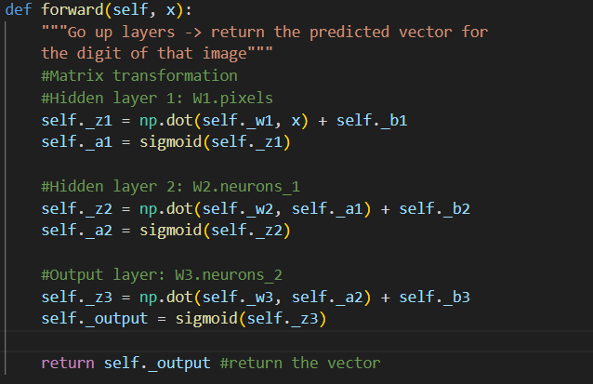
Forward function code snippet
self._z1 is the result of the first linear transformation using the weight matrix W1 and the bias b1(bias is set as 0 in this case):
$$z_{1}=W_{1}x$$
The sigmoid compresses any real number into a value between 0 and 1.
- If a component of z1 is large and positive → the sigmoid output (in a1) will be close to 1.
- If it is very negative → the output will be close to 0.
We then repeat this pattern (linear transformation → activation) for each layer until we produce the final output vector (z1 -> a1 -> z2 -> a2 -> z3 -> output).
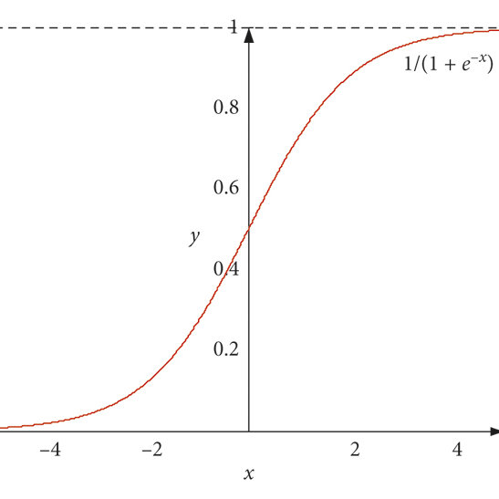
Sigmoid function
Initially, the predicted output is likely to be far from the actual expected result because the weights are randomly initialized. This is why training is necessary.
How can we update the weight through each training?
In Make Your Own Neural Network by Tariq Rashid, he mentions that the error can be distributed according to the contribution of each weight. As discussed earlier, if a neuron corresponding to a particular weight has a high activation, it indicates that the neuron is relevant. Therefore, we should assign a larger portion of the error to those weights during training.
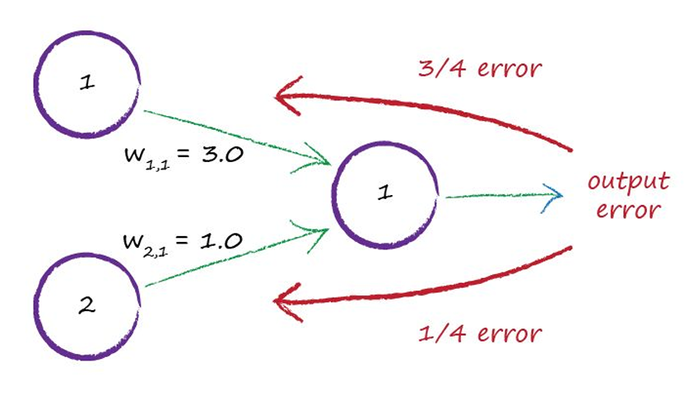
In the example on page 74 of Make Your Own Neural Network, we see that for small-weight values, W1,1 ​ contributes ¾ ​ of the output. Consequently, it receives ¾ of the output error. However, we do not need to explicitly calculate each weight’s portion of the contribution because weights with higher activation values are already larger. Therefore, we can simply multiply the weight by the error directly.
To update the weights, we need to compute the loss of our predicted output. There are many possible loss functions, but here we use the sum of the squared differences between the elements of the expected vector and the predicted vector.

Now, we need to compute how the loss changes with respect to the weights and biases. This is done by taking the partial derivatives of the multivariable loss function

